Diocese of Corpus Christi
Bishop’s Stewardship Appeal
2026 Social Media Guide

Title | Graphic Reference | Post Copy / Description
Caring for Retired Priests | 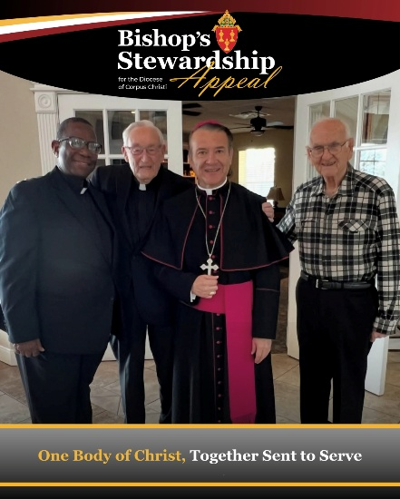 | As one Body of Christ, our diocesan and parish-based efforts are an important part of our shared call to discipleship. Working together through the Bishop’s Stewardship Appeal, we sustain the programs, pastoral services, schools, vocations, outreach, and care for retired clergy that serve every parish and community across our Diocese of Corpus Christi.  To learn more about the Bishop’s Stewardship Appeal, visit https://diocesecc.org/bsa.
Forming Disciples on Campus | 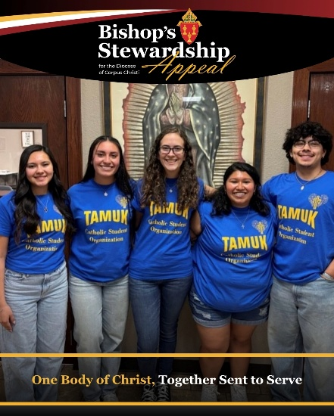 | Because of your generosity to the Bishop’s Stewardship Appeal, our youth and young adults are never alone on their journey. Gifts to the BSA directly support campus ministry in Corpus Christi, Beeville, and Kingsville. Thank you for investing in the future of our Church!  To learn more about the Bishop’s Annual Appeal or make a gift, visit https://diocesecc.org/bsa.
Forming Young Minds and Hearts | 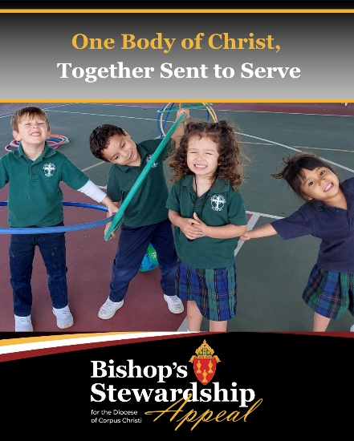 | Through support of donors to the Bishop Stewardship Appeal, Catholic education remains accessible and strong for families across our community. Thank you for supporting our schools and investing in the future of the Church!  To learn more about the Bishop’s Stewardship Appeal and make a gift to support Catholic Schools in the Diocese, visit: https://diocesecc.org/bsa.
Growing in Faith and Formation | 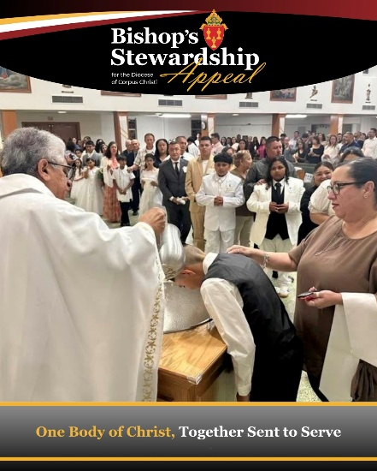 | Donors to the Bishop’s Stewardship Appeal play an important part of keeping the Catholic faith alive and flourishing in our Diocese with their generosity and prayers, giving hope to those who need it most.  To learn more about the Appeal and the Catholic ministries it supports, visit https://diocesecc.org/bsa.
Preparing Tomorrow’s Shepherds | 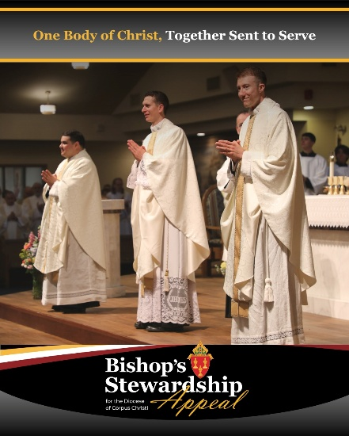 | We are currently blessed with three seminarians in formation, four young men discerning their call to the priesthood, and 19 men in formation for the permanent diaconate.  Did you know that by supporting the Bishop’s Stewardship Appeal you are directly funding faith formation and education of the future shepherds for the Diocese of Corpus Christi?  To support seminarians and so many other Catholic ministries, you can make a gift at https://give.diocesecc.org/!
Sharing the Good News | 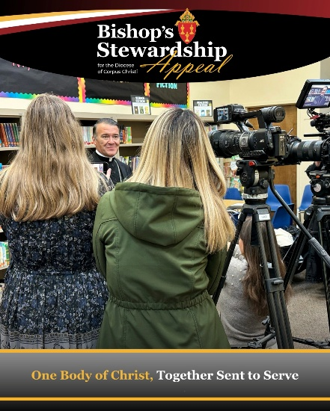 | Gifts to the Bishop’s Stewardship Appeal support Catholic ministries that reach every corner of the Diocese of Corpus Christi! To learn more about the Bishop’s Stewardship Appeal or make a gift, visit https://diocesecc.org/bsa.
Thank you | 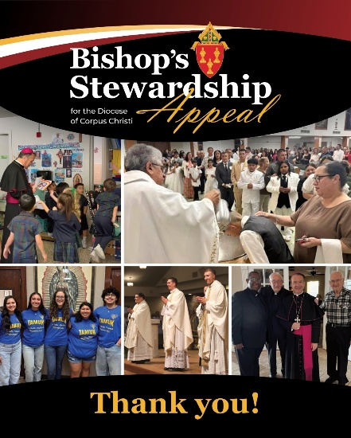 | Thank you! More than ### families have already made a gift to the Bishop’s Stewardship Appeal this year! This is a visible sign of unity, faith, and love in action.  Together, we can do extraordinary things.  Through the Bishop’s Stewardship Appeal, we are one body of Christ, together sent to serve.  Please complete a commitment form in your parish or visit https://give.diocesecc.org/ to make a safe, secure and online gift today!

